CS-320
Binathi
7-2 Project Two

Summary
My testing approach was aligned to the software requirements in many ways. First, I made sure to code according to the project requirements while also following coding practices to maintain quality and avoid repeating code. Next, I made sure to create the class files and JUnit test files for each class file. Another software requirement I followed is to make sure my environment was set up correctly to run the tests efficiently. I implemented this by making sure java build path libraries are set up correctly with JUnit testing so the test can run efficiently to determine if the tests passed, failed or detected errors.
Understanding the project requirements, I implemented the functionalities by storing the information then used input validation to limit how much of the information can be stored for each field of a contact. This also rejects any invalid information that exceeds length and displays error messages to the user.
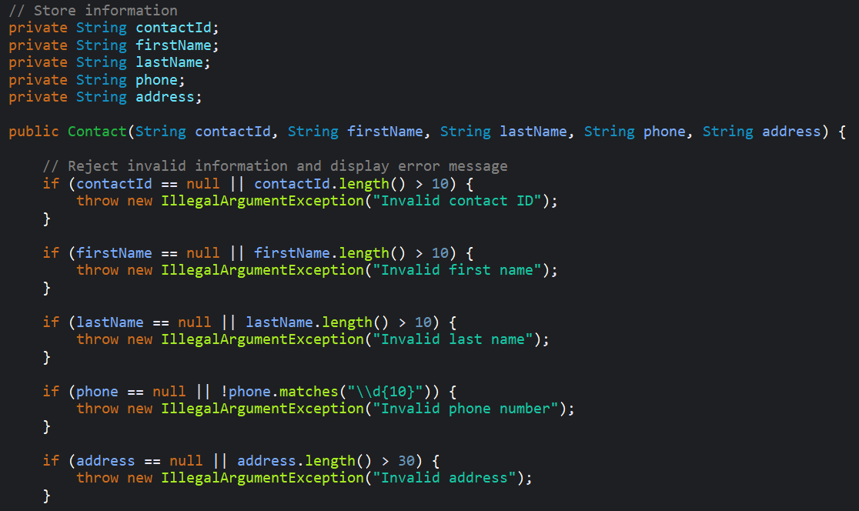
On the overall quality of the JUnit tests, I made sure to understand and implement the project requirements for each class file. Next, for each class I created a JUnit test case file with information that can be tested. The JUnit tests were successful as it resulted with runs: 6/6 meaning all 6 tests passed on all projects. As well as 0 errors and 0 failures.

I also used code coverage percentage to evaluate the efficiency of the JUnit tests because “Code coverage metrics measure the percentage of code that your unit tests execute (exercise) when run. Ostensibly, code that is covered is working, and code that is not covered represents the risk of breakage.” (Langr, 2024). The MobileApplication project contains the ContactService, TaskService and ApplicationService projects and resulted in 84.1% coverage, this means majority of the project code was executed and passed tests.
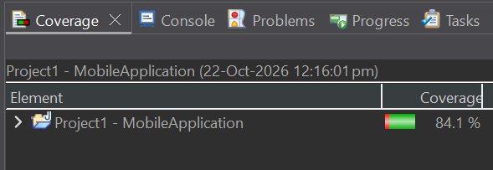

To make sure my code was technically sound, I stored information, called methods, used input validation and conducted multiple tests with valid information to check if all tests performed as expected and passed. To Illustrate, I chose the tests from the ContactServiceTest file, first I created an example contact using createContact() then I added the contact as a unique contact ID so an ID can be used in multiple tests.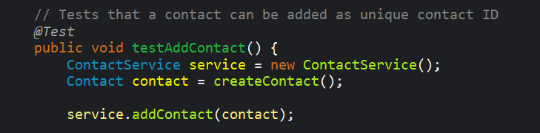

Once a contact is added as a Unique contact ID as shown in the test above, the same ID can be used in multiple tests to check if a contact already exists on the same ID with the test below. Using the same contact ID I conducted more tests to delete contacts or update contacts.
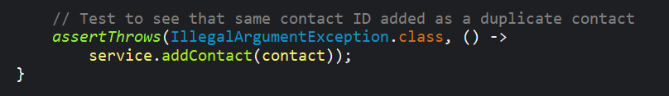

This is the code from the TaskTest file which shows that I created an example task with valid information containing taskID, task name, and task description that was used in all the tests to check if all tests functioned as expected and passed. Since the entire TaskService project resulted in 6/6, this means all tests passed with 0 failures and 0 errors.
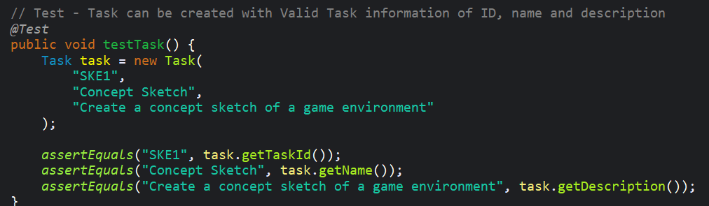
Reflection
The software testing techniques used for all milestones throughout ContactService, TaskService, and AppointmentService projects was requirements-based testing, unit testing and boundary value testing. For all these projects, I created class files and implemented the requirements inside. For each class file I created a JUnit test case file and created tests to check if each requirement's functionality passed and worked as expected. I also implemented boundary value testing to limit input values according to the requirement’s ranges.
Software testing techniques I did not use in these milestones is performance testing, which can help to analyze the application performance speed. This can be helpful when analyzing larger applications with high traffic. I also did not use integration testing, which tests if the components exchange information correctly. Security testing is another test I did not use but it helps identify weaknesses and vulnerabilities in an application, while also preventing data breaches and unauthorized access. Overall, there are many different testing methods that test different parts of an application and identify errors. It is important to use multiple tests to ensure the different aspects of the application are functioning correctly.
In software development projects the testing technique of requirements-based testing integrated with unit testing tests each requirement, class, and method separately. The practical uses of this is to check which methods and classes passed the tests successfully, while also determining which failed with errors. Overall, this breaks a larger project into smaller manageable sections instead of being overwhelmed by the entire project. I also implemented boundary value testing, the practical uses of this is to limit input values based on the requirements. This rejects any input values that do not meet the requirements and returns an error message to the user.
References

Langr, J. (2024). Pragmatic Unit Testing in Java with JUnit - Third Edition. EBSCO. https://research.ebsco.com/c/cyb354/ebook-viewer/pdf/uunz4xrpuv/page/pp_71?location=https%25253A%25252F%25252Fresearch.ebsco.com%25252Fc%25252Fcyb354%25252Fsearch%25252Fdetails%25252Fuunz4xrpuv

